|  |
| --- |
| Name: A.A. Yasiru Heshan Perera |
| Student Reference Number:10602294 |



|  |  |  |
| --- | --- | --- |
| Module Code: ISAD253SL | Module Name: Advanced Database Management System | |
| Coursework Title: Database for Lanka tours | | |
| Deadline Date:  1st January 2018 | | Member of staff responsible for coursework: |
| Programme: | | |
| Please note that University Academic Regulations are available under Rules and Regulations on the University website [www.plymouth.ac.uk/studenthandbook](http://www.plymouth.ac.uk/studenthandbook). | | |
| Group work: please list all names of all participants formally associated with this work and state whether the work was undertaken alone or as part of a team. Please note you may be required to identify individual responsibility for component parts.  10602294- A.A Yasiru Heshan Perera  10602165- R.Jegatheshan  10601896- B.M.U.S Basnayake  10601909- R.G.K.Dilshan  10601886- C.Shan Aluwihare  ***We confirm that we have read and understood the Plymouth University regulations relating to Assessment Offences and that we are aware of the possible penalties for any breach of these regulations. We confirm that this is the independent work of the group.***  Signed on behalf of the group: | | |
| Individual assignment: ***I confirm that I have read and understood the Plymouth University regulations relating to Assessment Offences and that I am aware of the possible penalties for any breach of these regulations. I confirm that this is my own independent work.***  Signed: | | |
| Use of translation software: failure to declare that translation software or a similar writing aid has been used will be treated as an assessment offence.  I *have used/not used translation software.  If used, please state name of software………………………………………………………………… | | |
| **Overall mark _____% Assessors Initials ______ Date_________** | | |

*Please delete as appropriateSci/ps/d:/students/cwkfrontcover/2013/14

**Content**

1. Introduction 3
2. EER Diagram 4
3. Assumptions 5
4. Relational Mapping 6
5. Normalization 8
6. Data Dictionaries 17
7. CREATE TABLE Statements 23
8. INSERT INTO Statements 44
9. CREATE TRIGGER Statements 65
10. CREATE FUNCTION Statements 72
11. CREATE VIEW Statements 76
12. CREATE PROCEDURE Statements 82
13. Critical Appraisal 86
14. Comments on further implementation 87
15. Work Load Matrix 88
16. Peer Review Form 89
17. TurnitingUK Originality Report 90

**Introduction**

Our main objective of this project was to implement a effective database management system to a touring company (Lanka Tours). Database management system of Lanka Tours contains Managers, Guides, Customers and Drivers as living objects and vehicles, accommodation places etc as Properties. Many Properties of this company like accommodation places are situated in different locations all over the country. This company divides its customers to two types. As current customers and old customers. Company Provides their customers with many facilities like wide rage of tours, tour guides, vehicles, accommodation places.

In the database design, we tried to store all of the important data about the entities and the main concentration was given to the customers. All the personal information and tour information of the customers are included in the dbms. The property details and employee details are also very crucial to the company. So in this dbms all of that details are stored in a good manner and they can be retrieved anytime if needed.

We Used Sql Sever to design the database design. We have used triggers, views, data validations and user defined functions to increase the efficiency of the database management system. We manage to come up with an effective database after many hours of hard work.

**EER Diagram**

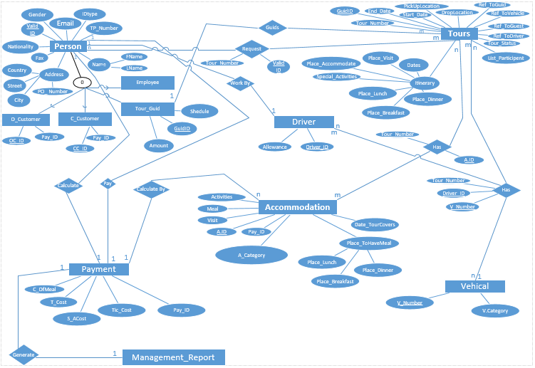

**ERD Assumptions**

1.One customer can request for many tours and one tour can be participate by many customers(they can be registered or not)

2.One tour guide can guide many tours but a single tour can only have one guide.

3.One tour can have many accommodation places, and one accommodation place can host many tours.

4.One driver can drive one vehicle at a single time, but one vehicle have many drivers on different tours.

5.One tour can have one or more vehicles and one vehicle can be participated to many tours.

**Relational Mapping**

|  |  |  |  |  |  |  |  |  |  |
| --- | --- | --- | --- | --- | --- | --- | --- | --- | --- |
| ValidID | IDType | FName | LName | Address | Gender | Email | TP_Number | Nationality | Fax |

**Person**

**O_Customer**

|  |  |  |
| --- | --- | --- |
| OC_ID | Valid_ID | Payment_ID |

**C_Customer**

|  |  |  |
| --- | --- | --- |
| CC_ID | Valid_ID | Payment_ID |

**Tour_Guid**

|  |  |  |  |
| --- | --- | --- | --- |
| Guid_ID | Valid_ID | Amount | Schedule |

**Employee**

|  |  |  |
| --- | --- | --- |
| Emp_ID | Valid_ID | Salary |

**Tours**

|  |  |  |  |  |  |
| --- | --- | --- | --- | --- | --- |
| Tour_Number | Guid_ID | FName | List_Participant | Tour_Status | Ref_ToDriver |
| Drop_Location | Pickup_Location | Start_Date | End_Date | No_OfDates | Itinerary |

**Vehicle**

|  |  |
| --- | --- |
| V_Number | Emp_ID |

**Driver**

|  |  |  |  |
| --- | --- | --- | --- |
| Driver_ID | Emp_ID | Allowance | Valid_ID |

**Accommodation**

|  |  |  |  |  |  |  |
| --- | --- | --- | --- | --- | --- | --- |
| A_ID | Activities | Meal | Visit | Date | Tour_Covers | Place_OfLunch |
| Payment | Pay_ID | C_OfMeal | S_ACost | Tick_Cost | T_Cost |

**Management Report**

|  |  |
| --- | --- |
| Report_ID | Pay_ID |

**Person_Tour**

|  |  |
| --- | --- |
| Tour_Number | Vaild_ID |

**Tour_Accommodation**

|  |  |
| --- | --- |
| Tour_Number | A_ID |

**Driver_Tour_Vehicle**

|  |  |  |
| --- | --- | --- |
| Tour_Number | Driver_ID | V_Number |

**Normalization**

**1st Normal Form(1 NF)**

A table must complete following functions in order to be in 1st normal form.

1. Table should not contain any composite attributes.
2. Table should not contain any attributes with multi values.
3. The entity should not have any nested relationships.

Person

|  |  |  |  |  |  |  |
| --- | --- | --- | --- | --- | --- | --- |
| Valid ID | ID type | Sender | Email | ID Number | Nationality | Fax |

|  |  |  |
| --- | --- | --- |
| Valid ID | F Name | L Name |

P Name

P Address

|  |  |  |  |  |
| --- | --- | --- | --- | --- |
| Valid ID | Country | Street | City | PO number |

OC_ID

|  |  |  |  |
| --- | --- | --- | --- |
| OC_ID | Valid_ID | Payment_ID | Reference to Guest |

C_Customer

|  |  |  |  |
| --- | --- | --- | --- |
| CC_ID | Valid_ID | Payment_ID | Reference to Guest |

Tour Guide

|  |  |  |  |  |
| --- | --- | --- | --- | --- |
| Guide_ID | Valid_ID | Amount | Schedule | Reference to Tour Guide |

Employee

|  |  |  |
| --- | --- | --- |
| End_ID | Valid_ID | Salary |

Tours

|  |  |  |  |  |  |
| --- | --- | --- | --- | --- | --- |
| Tour Number | Tour Status | Drop Location | Pickup Location | Start Date | End Date |

Tour_Participants

|  |  |
| --- | --- |
| Tour Number | Participants |

Tour_Itinerary

|  |  |  |  |  |  |  |  |
| --- | --- | --- | --- | --- | --- | --- | --- |
| Tour_Number | Date | Place Visit | Place accommodation | Special Activities | Place Lunch | Place_Breakfast | Place Dinner |

Vehicle

|  |  |  |
| --- | --- | --- |
| V_Number | Category | Reference to vehicles |

Driver

|  |  |  |  |  |
| --- | --- | --- | --- | --- |
| Driver_ID | allowances | EMP_ID | Preference to driver | Valid_ID |

Accommodation

|  |  |  |  |  |  |
| --- | --- | --- | --- | --- | --- |
| A_ID | Activities | Meal | Visit | Dates | Payment_ID |

Accommodation_ Category

|  |  |
| --- | --- |
| A_ID | A_Category |

Accommodation_Place to have meal

|  |  |  |  |  |
| --- | --- | --- | --- | --- |
| A_ID | Place lunch | Place Meal | Place Breakfast | Place Dinner |

Payment

|  |  |  |  |  |
| --- | --- | --- | --- | --- |
| Payment_ID | C_of meal | T_cost | S_A cost | Tic_Cost |

Management Report

|  |  |
| --- | --- |
| Report_ID | Day_ID |

Person_Tour

|  |  |
| --- | --- |
| Tour_Number | Valid_ID |

Tours_Accommodation

|  |  |
| --- | --- |
| Tours_Number | A_ID |

Driver_Tour_Vehicle

|  |  |  |
| --- | --- | --- |
| Tour Number | Driver_ID | V_Number |

**2nd Normal Form (2 NF)**

If a relation is in 1st normal form and it’s every non-primary key attribute of the table are fully dependent on its primary key attribute.

If any relation is not, than the partial dependencies of them should be resolved in order to arrange them in 2nd normal form.

There are no any non-primary key attributes which are partially dependent on its primary key.

Person

|  |  |  |  |
| --- | --- | --- | --- |
| Valid_ID | ID_Type | Gender | Nationality |

Person_Contact

|  |  |  |  |
| --- | --- | --- | --- |
| Valid_ID | Email | TPNumber | Fax |

P_Name

|  |  |  |
| --- | --- | --- |
| Valid_ID | FName | LName |

P_Address

|  |  |  |  |  |
| --- | --- | --- | --- | --- |
| Valid_ID | Country | Street | City | PO_Number |

O_Customer

|  |  |  |  |
| --- | --- | --- | --- |
| OC_ID | Valid_ID | Payment_ID | Reference_ToGuest |

C_Customer

|  |  |  |  |
| --- | --- | --- | --- |
| CC_ID | Valid_ID | Payment_ID | Reference_ToGuest |

Tour_Guid

|  |  |  |  |  |
| --- | --- | --- | --- | --- |
| Guid_ID | Valid_ID | Amount | Schedule | Reference_ToGuest |

Employee

|  |  |  |
| --- | --- | --- |
| Emp_ID | Valid_ID | Salary |

Tours

|  |  |  |  |  |  |
| --- | --- | --- | --- | --- | --- |
| Tour_Number | Tour_Status | Pickup_Location | Drop_Location | Start_Date | End_Date |

Tour_Participants

|  |  |
| --- | --- |
| Tour_Number | Participants |

Tour_Itinerary

|  |  |  |  |  |  |
| --- | --- | --- | --- | --- | --- |
| Tour_Number | Dates | Place_Vist | Place_Breakfirst | Place_OfLunch | Place_OfDinner |

Vehicle

|  |  |  |
| --- | --- | --- |
| V_Number | Category | Reference_ToVehicle |

Driver

|  |  |  |  |
| --- | --- | --- | --- |
| Driver_ID | Allowances | Emp_ID | Reference_ToDriver |

Accommodation

|  |  |  |  |  |
| --- | --- | --- | --- | --- |
| A_ID | Visit | Dates | Payment_ID | A_Category |

Accommodation_Category

|  |  |
| --- | --- |
| A_ID | A_Category |

Accommodation_PlaceTohavemeal

|  |  |  |  |
| --- | --- | --- | --- |
| A_ID | Place_OfBreakfirst | Place_OfLunch | Place_OfDinner |

Payment

|  |  |  |  |  |
| --- | --- | --- | --- | --- |
| Payment_ID | C_OfMeal | S_ACost | TIC_Cost | T_Cost |

Management_Report

|  |  |  |
| --- | --- | --- |
| Receipt_ID | Payment_ID | Report_Description |

Person_Tour

|  |  |
| --- | --- |
| Tour_Number | Valid_ID |

Tours_Accommodations

|  |  |
| --- | --- |
| Tours_Number | A_ID |

Driver_Tour_Vehicle

|  |  |  |
| --- | --- | --- |
| Tour_Number | Driver_ID | V_Number |

**3rd Normal Form (3 NF)**

Every relation in database must be in 2nd normal form as well as its non-primary key attributes should

Not be transitively depend on its primary key.

If any transitive dependency is existing, then it should be removed by separating the transitively dependent attribute from the existing relation and placing them in a new relation.

Person

|  |  |  |  |
| --- | --- | --- | --- |
| Valid_ID | ID_Type | Gender | Nationality |

Person_Contact

|  |  |  |  |
| --- | --- | --- | --- |
| Valid_ID | Email | TPNumber | Fax |

P_Address

|  |  |  |  |  |
| --- | --- | --- | --- | --- |
| Valid_ID | Country | Street | City | PO_Number |

P_Name

|  |  |  |
| --- | --- | --- |
| Valid_ID | FName | LName |

O_Customer

|  |  |  |  |
| --- | --- | --- | --- |
| OC_ID | Valid_ID | Payment_ID | Reference_ToGuest |

C_Customer

|  |  |  |  |
| --- | --- | --- | --- |
| CC_ID | Valid_ID | Payment_ID | Reference_ToGuest |

Tour_Guid

|  |  |  |  |  |
| --- | --- | --- | --- | --- |
| Guid_ID | Valid_ID | Amount | Schedule | Reference_ToGuest |

Employee

|  |  |  |
| --- | --- | --- |
| Emp_ID | Valid_ID | Salary |

Tours

|  |  |  |  |  |  |
| --- | --- | --- | --- | --- | --- |
| Tour_Number | Tour_Status | Pickup_Location | Drop_Location | Start_Date | End_Date |

Tour_Participants

|  |  |
| --- | --- |
| Tour_Number | Participants |

Tour_Itinerary

|  |  |  |  |  |  |
| --- | --- | --- | --- | --- | --- |
| Tour_Number | Dates | Place_Vist | Place_Breakfirst | Place_OfLunch | Place_OfDinner |

Tour_SPActivity

|  |  |  |
| --- | --- | --- |
| Special_Activities | Place_OfAccommodate | Tour_Number |

Vehicle

|  |  |  |
| --- | --- | --- |
| V_Number | Category | Reference_ToVehicle |

Driver

|  |  |  |  |
| --- | --- | --- | --- |
| Driver_ID | Allowances | Emp_ID | Reference_ToDriver |

Accommodation

|  |  |  |  |  |
| --- | --- | --- | --- | --- |
| A_ID | Visit | Dates | Payment_ID | A_Category |

Acc_Activities

|  |  |
| --- | --- |
| A_ID | Activities |

Accommodation_PlaceTohavemeal

|  |  |  |  |
| --- | --- | --- | --- |
| A_ID | Place_OfBreakfirst | Place_OfLunch | Place_OfDinner |

Payment

|  |  |  |  |  |
| --- | --- | --- | --- | --- |
| Payment_ID | C_OfMeal | S_ACost | TIC_Cost | T_Cost |

Management_Report

|  |  |  |
| --- | --- | --- |
| Receipt_ID | Payment_ID | Report_Description |

Person_Tour

|  |  |
| --- | --- |
| Tour_Number | Valid_ID |

Tours_Accommodations

|  |  |
| --- | --- |
| Tours_Number | A_ID |

Driver_Tour_Vehicle

|  |  |  |
| --- | --- | --- |
| Tour_Number | Driver_ID | V_Number |

**Data Dictionaries**

Person Table

|  |  |  |  |
| --- | --- | --- | --- |
| **Field Name** | **Data type** | **Field Size** | **Constrains** |
| ValidId | varchar | 11 | Unique  Primary Key |
| IDtype | varchar | 10 | Not Null |
| Gender | varchar | 7 | Not Null |
| Nationality | varchar | 12 | Not Null |

Person_Contact Table

|  |  |  |  |
| --- | --- | --- | --- |
| **Field Name** | **Data type** | **Field Size** | **Constrains** |
| ValidId | varchar | 11 | Unique  Primary Key |
| Email | varchar | 35 | Not Null |
| Tp | varchar | 11 | Not Null |
| Fax | varchar | 15 | Not Null |

Person_Address Table

|  |  |  |  |
| --- | --- | --- | --- |
| **Field Name** | **Data type** | **Field Size** | **Constrains** |
| ValidId | varchar | 11 | Unique  Primary Key |
| Country | varchar | 25 | Not Null |
| Street | varchar | 25 | Not Null |
| City | varchar | 15 | Not Null |
| ponumber | varchar | 6 | Not Null |

Person_name Table

|  |  |  |  |
| --- | --- | --- | --- |
| **Field Name** | **Data type** | **Field Size** | **Constrains** |
| ValidId | varchar | 11 | Unique  Primary Key |
| F_name | varchar | 15 | Not Null |
| L_name | varchar | 15 | Not Null |

Old_Customers Table

|  |  |  |  |
| --- | --- | --- | --- |
| **Field Name** | **Data type** | **Field Size** | **Constrains** |
| ValidId | varchar | 11 | Unique  Primary Key |
| PaymentID | varchar | 8 | Foreign Key  Unique  Not Null |
| Refference | varchar | 30 | Foreign Key  Unique  Not Null |

Current_Customers Table

|  |  |  |  |
| --- | --- | --- | --- |
| **Field Name** | **Data type** | **Field Size** | **Constrains** |
| ValidId | varchar | 11 | Unique  Primary Key |
| PaymentID | varchar | 8 | Foreign Key  Unique  Not Null |
| Refference | varchar | 30 | Foreign Key  Unique  Null |

Tour_Guide Table

|  |  |  |  |
| --- | --- | --- | --- |
| **Field Name** | **Data type** | **Field Size** | **Constrains** |
| GuidId | varchar | 4 | Unique  Primary Key |
| ValidID | varchar | 11 | Unique  Not Null  Foreign Id |
| EmpId | varchar | 5 | Unique  Not Null  Foreign Id |
| Shedule | varchar | 40 | Not Null |
| RefferenceToGuid | varchar | 40 | Null |

Employee Table

|  |  |  |  |
| --- | --- | --- | --- |
| **Field Name** | **Data type** | **Field Size** | **Constrains** |
| EmpId | varchar | 5 | Unique  Primary Key |
| ValidID | varchar | 11 | Foreign Key  Unique  Not Null |
| Salary | int |  | Not Null |

Tours Table

|  |  |  |  |
| --- | --- | --- | --- |
| **Field Name** | **Data type** | **Field Size** | **Constrains** |
| TourNumber | varchar | 4 | Unique  Primary Key |
| TourStartLocation | varchar | 15 | Not Null |
| PicupLocation | varchar | 15 | Not Null |
| DropLocation | varchar | 15 | Not Null |
| StartDate | Date |  | Not Null |
| EndDate | Date |  | Not Null |

Tour_Participents Table

|  |  |  |  |
| --- | --- | --- | --- |
| **Field Name** | **Data type** | **Field Size** | **Constrains** |
| TourNumber | varchar | 4 | Unique  Primary Key |
| Numberofparticipents | int |  | Not Null |

Tour_Itinarary Table

|  |  |  |  |
| --- | --- | --- | --- |
| **Field Name** | **Data type** | **Field Size** | **Constrains** |
| TourNumber | varchar | 4 | Unique  Foreign Key |
| NumberofDates | int |  | Not Null |
| PlaceVisit | varchar | 20 | Not Null |
| Placebreakfast | varchar | 20 | Not Null |
| Placelunch | varchar | 20 | Not Null |
| PlaceDinner | varchar | 20 | Not Null |

Tour_SpecialActivities Table

|  |  |  |  |
| --- | --- | --- | --- |
| **Field Name** | **Data type** | **Field Size** | **Constrains** |
| TourNumber | varchar | 4 | Unique  Foreign Key |
| SpecialActivities | varchar | 25 | Not Null |
| PlaceOfAccomodation | varchar | 35 | Not Null |

Vehical Table

|  |  |  |  |
| --- | --- | --- | --- |
| **Field Name** | **Data type** | **Field Size** | **Constrains** |
| VehicalNo | varchar | 15 | Unique  Primary Key |
| Category | varchar | 5 | Not Null |
| ReferenceToVehical | varchar | 35 | Not Null |

Driver Table

|  |  |  |  |
| --- | --- | --- | --- |
| **Field Name** | **Data type** | **Field Size** | **Constrains** |
| DriverID | varchar | 5 | Unique  Foreign Key  Not Null |
| Allowences | int |  | Not Null |
| EmpID | varchar | 5 | Not Null  Unique  Foreign Key |
| RefferenceToDriver | varchar | 30 | Not Null |

Accomodation Table

|  |  |  |  |
| --- | --- | --- | --- |
| **Field Name** | **Data type** | **Field Size** | **Constrains** |
| AID | varchar | 7 | Unique  Primary Key |
| Visit | varchar | 20 | Not Null |
| NoofDates | int |  | Not Null |
| AccomodationCategory | varchar | 10 | Not Null |
| PaymentId | varchar | 8 | Unique  Foreign Key |

Accomodation_PlacetohaveMeal Table

|  |  |  |  |
| --- | --- | --- | --- |
| **Field Name** | **Data type** | **Field Size** | **Constrains** |
| AID | varchar | 7 | Unique  Foreign Key  Not Null |
| Place_breakfast | varchar | 20 | Not Null |
| Place_lunch | varchar | 20 | Not Null |
| Place_dinner | varchar | 20 | Not Null |

Payment Table

|  |  |  |  |
| --- | --- | --- | --- |
| **Field Name** | **Data type** | **Field Size** | **Constrains** |
| PaymentId | varchar | 8 | Unique  Primary Key  Not Null |
| CostOfMeals | integer |  | Not Null |
| TicketCost | integer |  | Not Null |
| Sumof_Acccost | integer |  | Not Null |
| Total_Cost | integer |  | Not Null |

Management_Report Table

|  |  |  |  |
| --- | --- | --- | --- |
| **Field Name** | **Data type** | **Field Size** | **Constrains** |
| ReportID | varchar | 6 | Unique  Primary Key  Not Null |
| Recipt_Detail | int |  | Not Null |
| PaymentID | varchar | 8 | Not Null  Unique  Foreign Key |

Person_Tour Table

|  |  |  |  |
| --- | --- | --- | --- |
| **Field Name** | **Data type** | **Field Size** | **Constrains** |
| ValidID | varchar | 11 | Unique  Foreign Key  Not Null |
| TotalNumber | varchar | 4 | Not Null  Unique  Foreign Key |

Tour_Accomodation Table

|  |  |  |  |
| --- | --- | --- | --- |
| **Field Name** | **Data type** | **Field Size** | **Constrains** |
| TourNumber | varchar | 4 | Unique  Foreign Key  Not Null |
| AID | varchar | 7 | Not Null  Unique  Foreign Key |

Driver_Tour_Vehicle Table

|  |  |  |  |
| --- | --- | --- | --- |
| **Field Name** | **Data type** | **Field Size** | **Constrains** |
| DriverID | varchar | 5 | Unique  Foreign Key  Not Null |
| TourNumber | varchar | 4 | Not Null  Unique  Foreign Key |
| VehicleNumber | varchar | 15 | Not Null  Unique  Foreign Key |

**CREATE TABLE Statements**

CREATE TABLE PersonTable(ValidID varchar(11) UNIQUE NOT NULL,

IDtype varchar(10) NOT NULL,

Gender varchar(7) NOT NULL,

Nationality varchar(12) NOT NULL,

Constraint pk_ValidID PRIMARY KEY(ValidID));

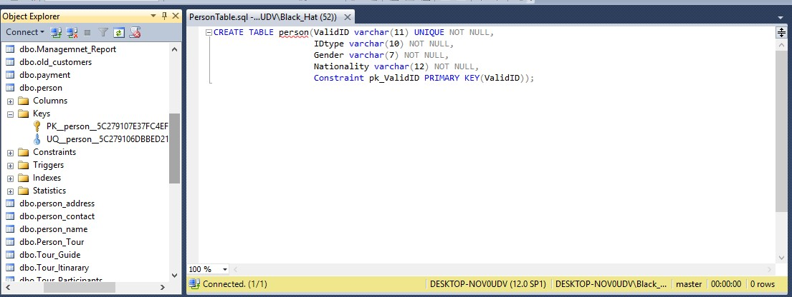

CREATE TABLE PersonContact ( ValidId varchar(11) UNIQUE NOT NULL,

Email varchar (35) NULL,

TpNumber varchar(11) NOT NULL,

Fax varchar (15) NOT NULL,

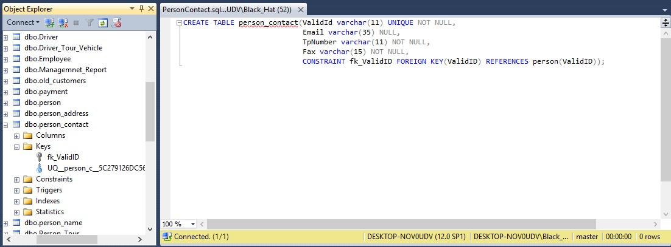CONSTRAINT fk_ValidID FOREIGN KEY (ValidID) REFERENCES person (ValidID));

CREATE TABLE personAddressTable(ValidID varchar(11) UNIQUE NOT NULL,

Country varchar (25) NULL,

Street varchar (25) NOT NULL,

City varchar (15) NOT NULL,

PoNumber varchar (6) NOT NULL,

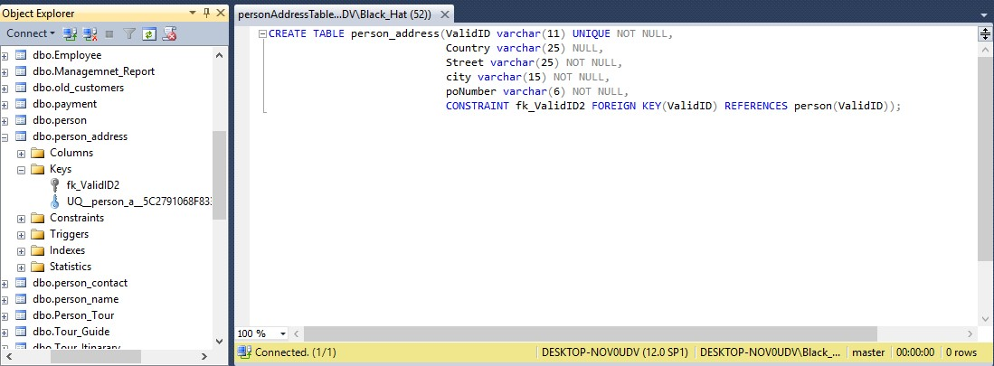CONTRAINT fk_ValidID2 FOREIGN KEY (ValidID) REFERENCES person(ValidID));

CREATE TABLE personNameTable (ValidID varchar (11) UNIQUE NOT NULL,

F_name varchar (15) NOT NULL,

L_name varchar (15) NOT NULL,

CONTRAINT fk_ValidID3 FOREIGN KEY (ValidID) REFERENCES person(ValidID));

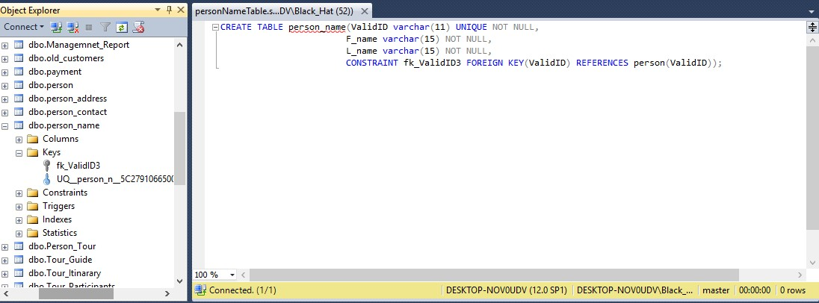

CREATE TABLE oldCustomersTable (ocID varchar (3) UNIQUE NOT NULL,

ValidID varchar (11) UNIQUE NOT NULL,

PaymentID varchar (8) UNIQUE NOT NULL,

Refference varchar (30) NOT NULL,

Constraint pk_ocID3 PRIMARY KEY (ocID),

Constraint fk_ValidID4 FOREIGN KEY (ValidID) REFERENCES person(ValidID));

Constraint fk_PaymentID FOREIGN KEY (PaymentID) REFERENCES payment(PaymentID));

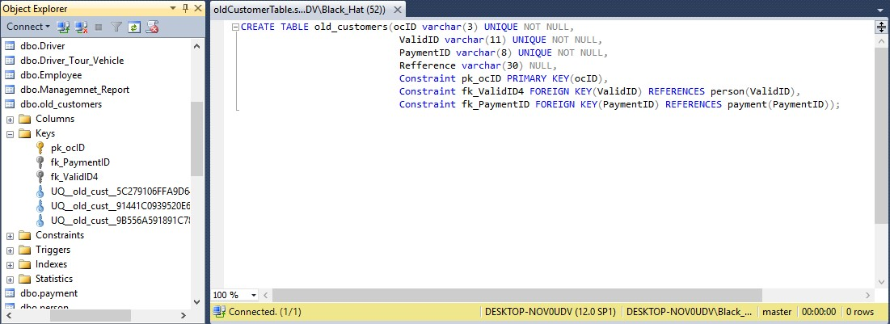

CREATE TABLE currentCustomersTable (ccID varchar (3) UNIQUE NOT NULL,

ValidID varchar (11) UNIQUE NOT NULL,

PaymentID varchar (8) UNIQUE NOT NULL,

Refference varchar (30) NOT NULL,

Constraint pk_ccID3 PRIMARY KEY (ccID),

Constraint fk_ValidID5 FOREIGN KEY (ValidID) REFERENCES person(ValidID));

Constraint fk_PaymentID2 FOREIGN KEY (PaymentID) REFERENCES payment(PaymentID));

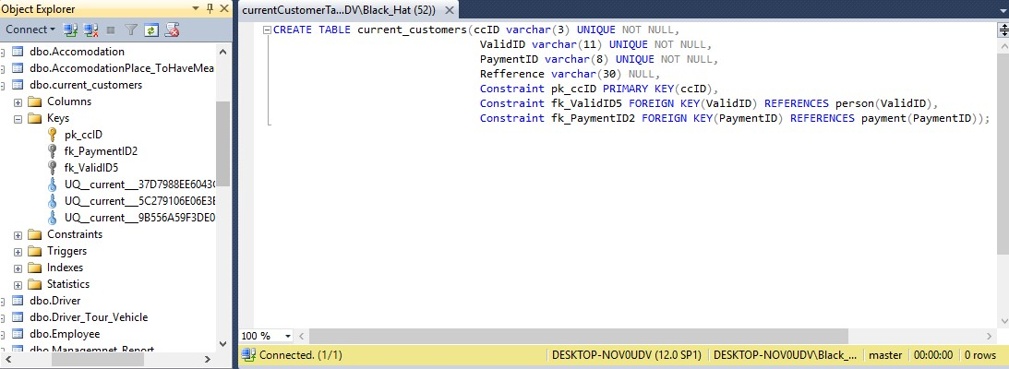

CREATE TABLE TourGuideTable (guideID varchar (4) UNIQUE NOT NULL,

ValidID varchar (11) UNIQUE NOT NULL,

EmpID varchar (5) UNIQUE NOT NULL,

Shadule varchar (40) NOT NULL,

RefferenceToGuide varchar (40) NULL,

Constraint pk_guideID3 PRIMARY KEY (guideID),

Constraint fk_ValidID7 FOREIGN KEY (ValidID) REFERENCES person(ValidID));

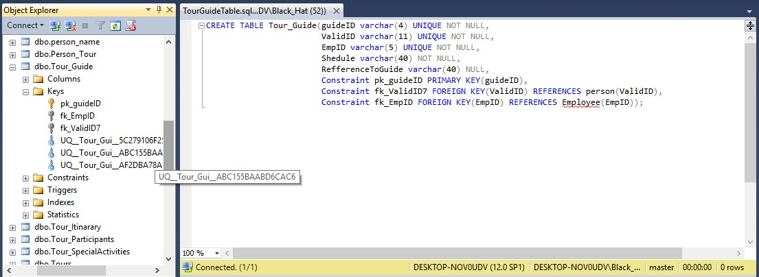 Constraint fk_EmpID FOREIGN KEY (EmpID) REFERENCES payment(EmpID));

CREATE TABLE EmployeeTable (EmpID varchar (5) UNIQUE NOT NULL,

ValidID varchar (11) UNIQUE NOT NULL,

Salary int NOT NULL,

Constraint pk_EmpID PRIMARY KEY (EmpID),

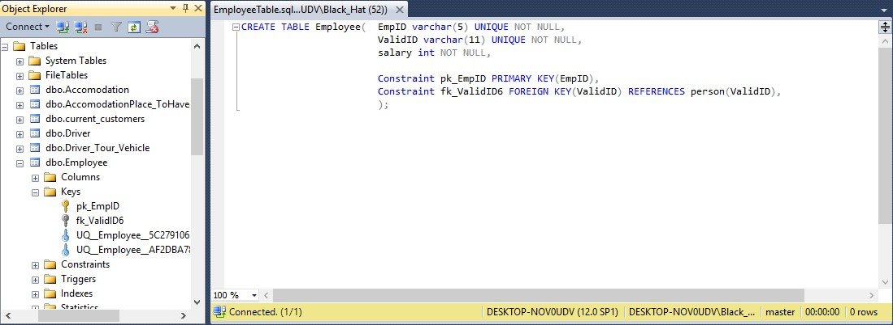 Constraint fk_ValidID6 FOREIGN KEY (ValidID) REFERENCES person(ValidID));

CREATE TABLE ToursTable (TourNumber varchar (4) UNIQUE NOT NULL,

TourStartLocation varchar (15) NOT NULL,

PicupLocation varchar (15) NOT NULL,

DropLocation varchar (15) NOT NULL,

StartDate date NOT NULL,

endDate date NOT NULL,

Constraint pk_TourNumber PRIMARY KEY (TourNumber));

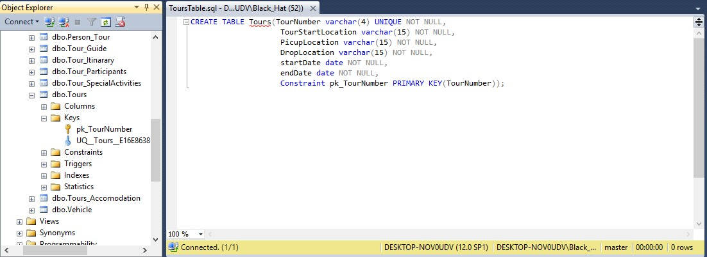

CREATE TABLE TourParticipantsTable (TourNumber varchar (4) UNIQUE NOT NULL,

NumberOfParticipants int NOT NULL,

Constraint fk_TourNumber FOREIGN KEY (TourNumber) REFERENCES Tours(TourNumber));

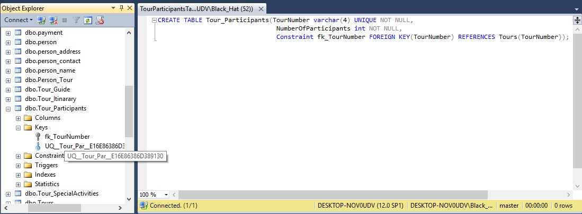

CREATE TABLE TourItinararyTable (TourNumber varchar (4) UNIQUE NOT NULL,

NumberOfDays int NOT NULL,

PlaceVisit varchar (20) NOT NULL,

PlaceBreakfast varchar (10) NULL,

PlaceLunch varchar (10) NULL,

PlaceDinner varchar (10) NULL,

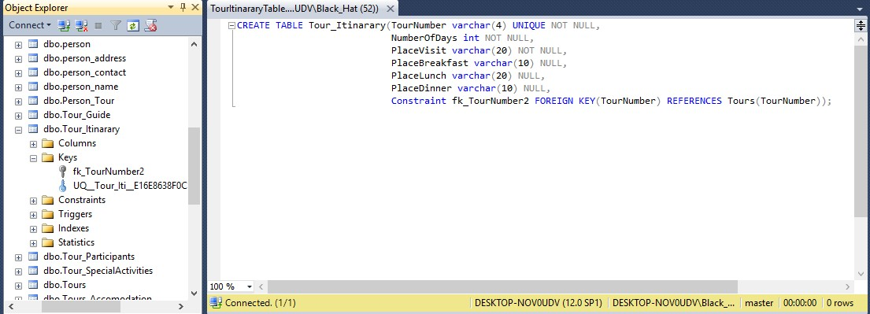Constraint fk_TourNumber2 FOREIGN KEY (TourNumber) REFERENCES Tours(TourNumber));

CREATE TABLE TourSpecialActivities (TourNumber varchar (4) UNIQUE NOT NULL,

SpecialActivity varchar (25) NOT NULL,

PlaceOfAccomodation varchar (35) NOT NULL,

Constraint fk_TourNumber3 FOREIGN KEY (TourNumber) REFERENCES person(TourNumber));

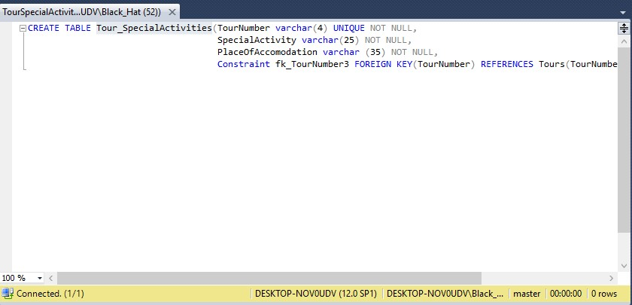

CREATE TABLE VehicleTable (VehicalNo varchar (15) UNIQUE NOT NULL,

Category varchar (5) NOT NULL,

ReferenceToVehicle varchar (35) NOT NULL,

Constraint pk_VehicleNo PRIMARY KEY (VehivelNo));

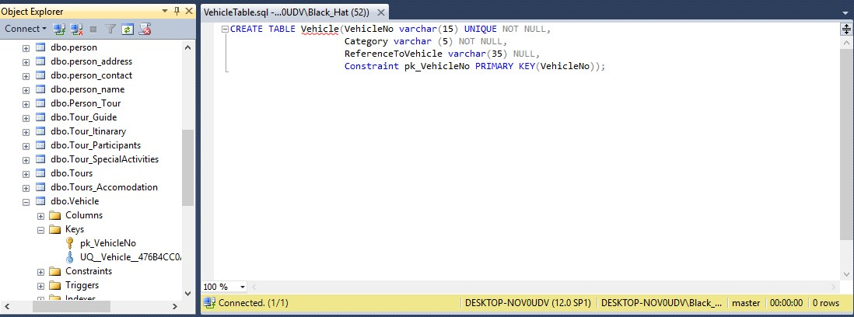

CREATE TABLE DriverTable (DriverID varchar (5) UNIQUE NOT NULL,

Allowances int NOT NULL,

EmpID varchar (5) UNIQUE NOT NULL,

ReferenceToDriver varchar (30) NULL,

Constraint pk_DriverID PRIMARY KEY (DriverID),

Constraint fk_EmpID3 FOREIGN KEY (EmpID) REFERENCES Employee (EmpID));

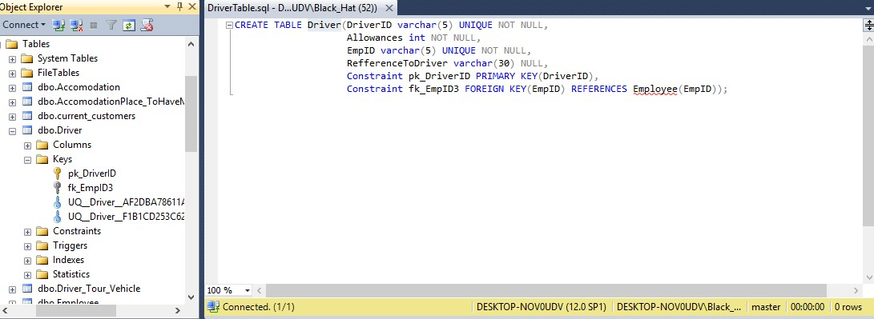

CREATE TABLE AccomodationTable(AID varchar (7) UNIQUE NOT NULL,

Visit varchar (20) NOT NULL,

NoOfDates int NOT NULL,

AccomodationCategory varchar 10 NOT NULL,

PaymentID varchar (8) UNIQUE NOT NULL,

Constraint pk_AID PRIMARY KEY (AID),

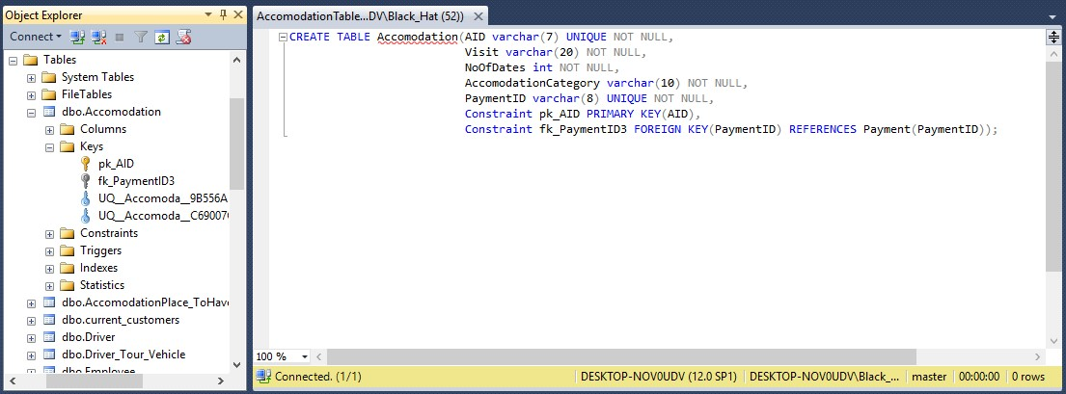Constraint fk_PaymentID3 FOREIGN KEY (Payment ID) REFERENCES Payment (PaymentID));

CREATE TABLE AccomodationPlaceToHAveMeal(AID varchar (7) UNIQUE NOT NULL,

PlaceBreakfast varchar (20) NULL,

PlaceLunch varchar (20) NULL,

PlaceDinner varchar (20) NULL,

Constraint fk_AID FOREIGN KEY (AID) REFERENCES Accomodation (AID));

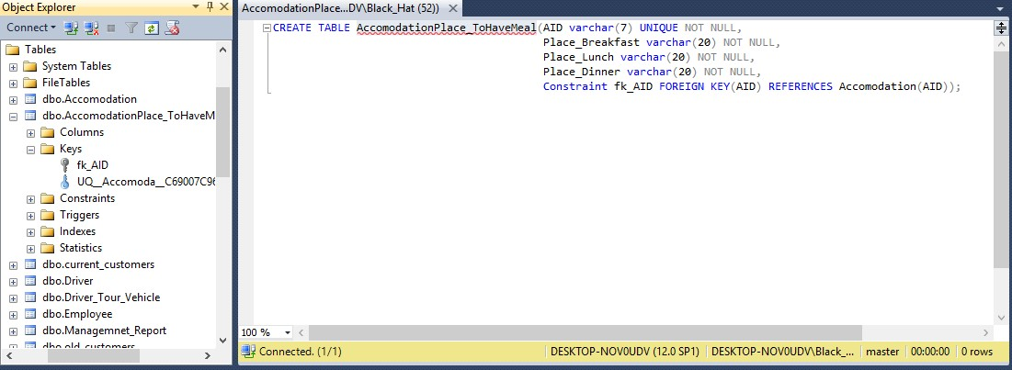

CREATE TABLE paymentTable(PaymentID varchar (8) UNIQUE NOT NULL,

CostOfMeal integer NOT NULL,

TicketCost integer NOT NULL,

SumOf_AccCost integer NOT NULL,

TotalCost integer NOT NULL,

Constraint pk_PaymentID PRIMARY KEY (PaymentID));

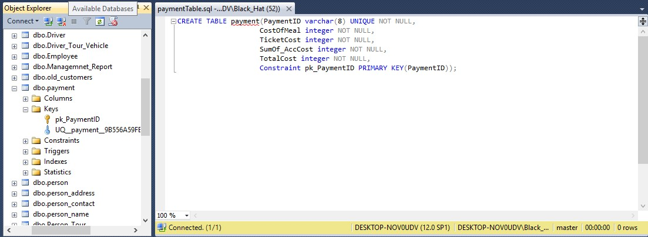

CREATE TABLE ManagementReport(ReportID varchar (6) UNIQUE NOT NULL,

Recipt_Detail int NOT NULL,

PaymentID varchar (8) UNIQUE NOT NULL,

Constraint pk_Report PRIMARY KEY (ReportID),

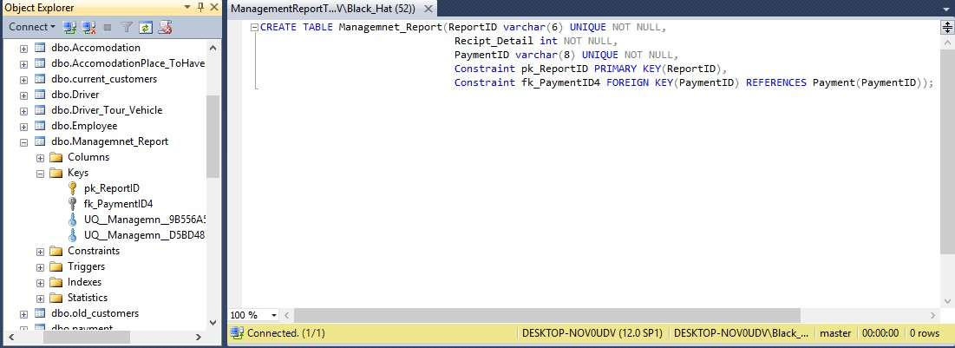Constraint fk_PaymentID4 FOREIGN KEY (Payment ID) REFERENCES Payment (PaymentID));

CREATE TABLE Person_TourTable(ValidID varchar (11) UNIQUE NOT NULL,

TourNumber varchar (4) UNIQUE NOT NULL,

Constraint fk_ValidID9 FOREIGN KEY (ValidID) REFERENCES person (ValidID));

Constraint fk_TourNumber9 FOREIGN KEY (TourNumber) REFERENCES Tours(TourNumber));

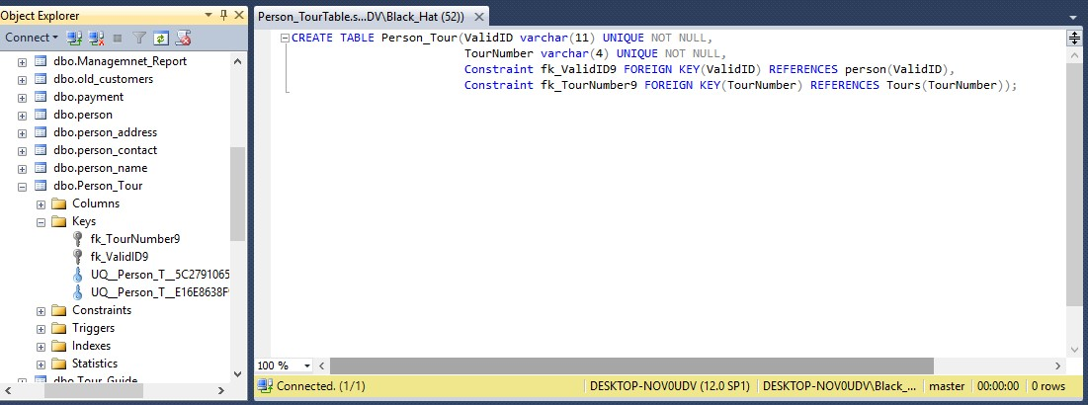

CREATE TABLE Tour_Accomodation(TourNumber varchar (4) UNIQUE NOT NULL,

AID varchar (7) UNIQUE NOT NULL,

Constraint fk_TourNumber10 FOREIGN KEY (TourNumber) REFERENCES Tours (TourNumber),

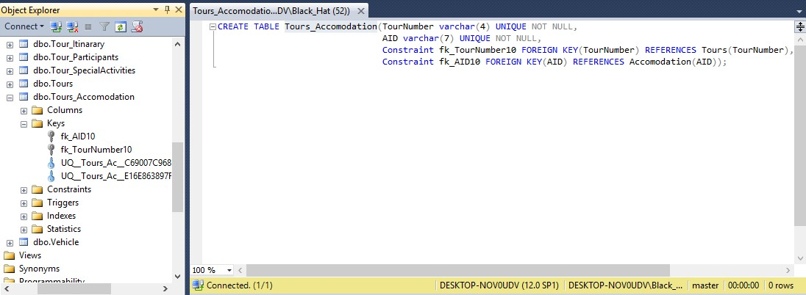Constraint fk_AID10 FOREIGN KEY (AID) REFERENCES Accomodation(AID));

CREATE TABLE Driver_Tour_VehicleTable(DriverID varchar (5) UNIQUE NOT NULL,

TourNumber varchar (4) UNIQUE NOT NULL,

VehicleNo varchar (15) UNIQUE NOT NULL,

Constraint fk_DriverID11 FOREIGN KEY (DriverID ) REFERENCES DriverID(DriverID),

Constraint fk_TourNumber FOREIGN KEY (TourNumber) REFERENCES Tours(TourNumber),

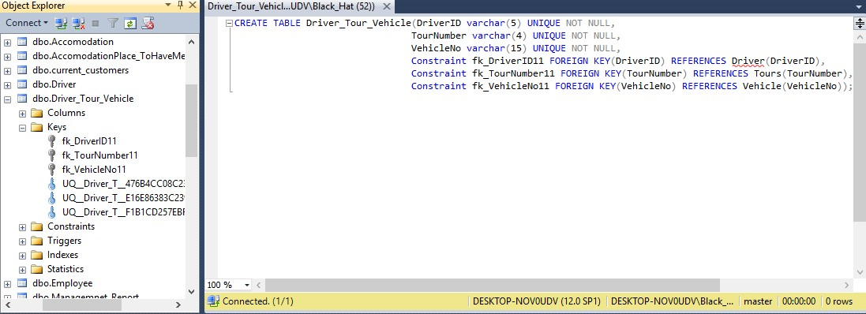Constraint fk_ VehicleNo11 FOREIGN KEY (VehicleNo) REFERENCES Vehicle(VehicleNo));

**INSERT INTO Statement**

Person Table

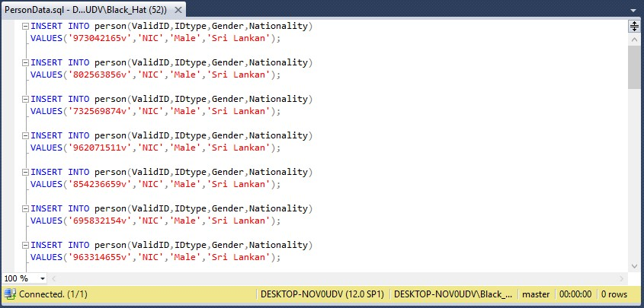

PersonContact Table

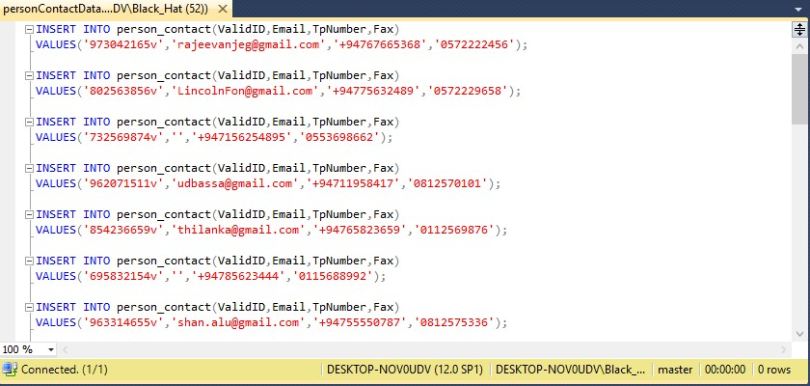

PersonAddress Table

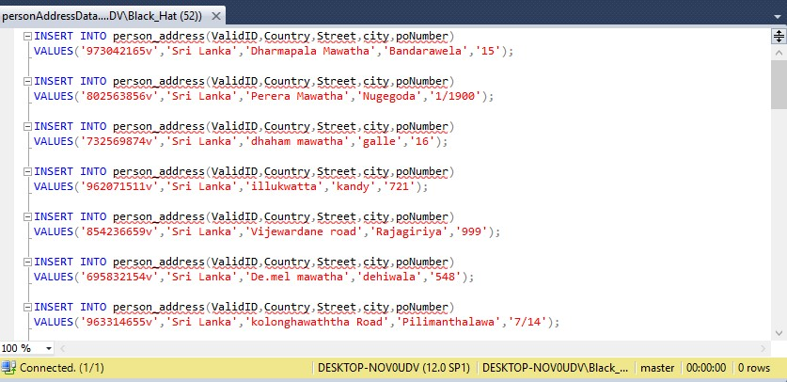

PersonName Table

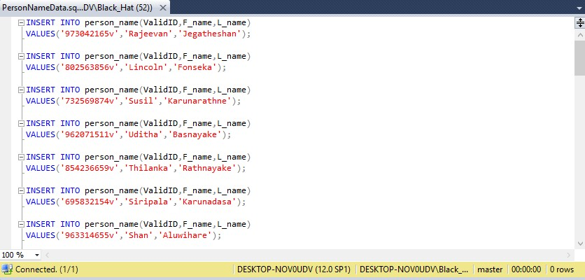

OldCustomer Table

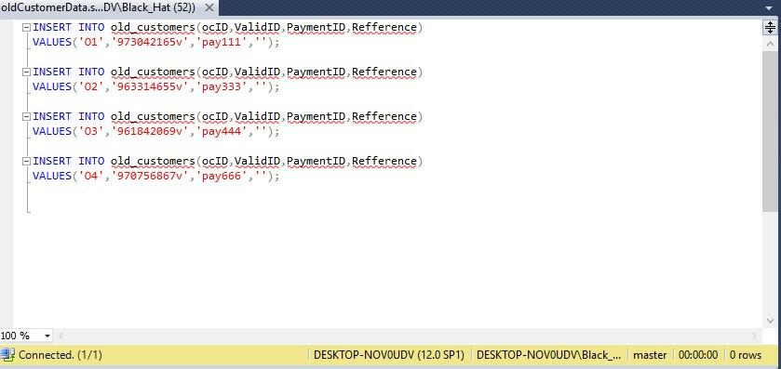

Current Customer Table

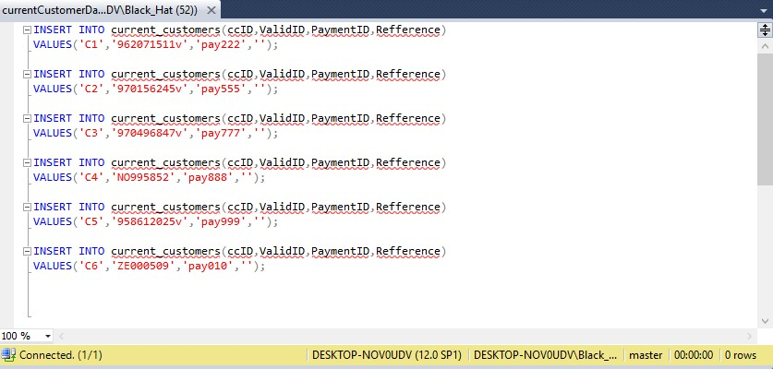

TourGuid Table

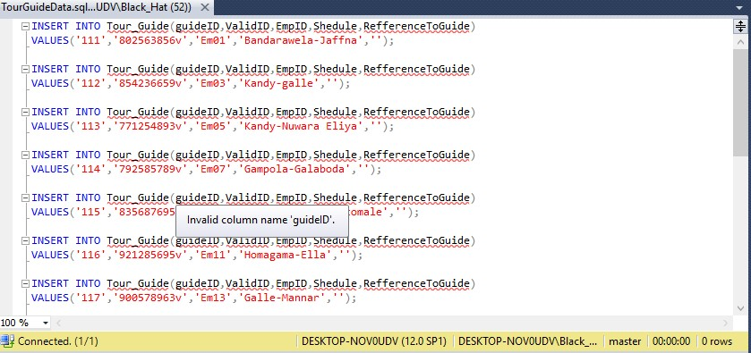

Employee Table

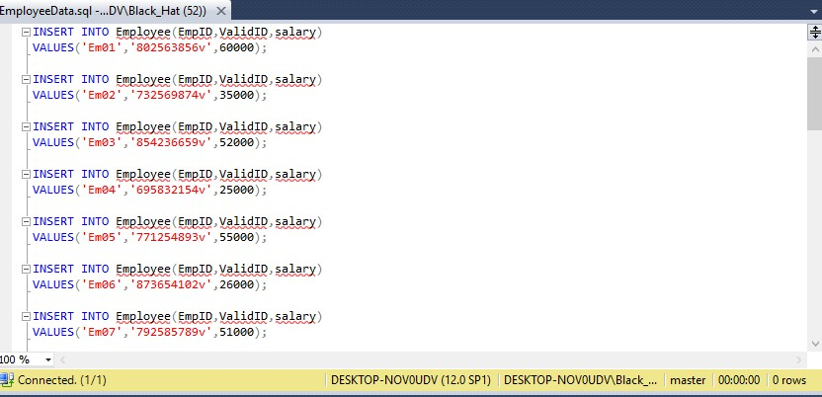

Tours Table

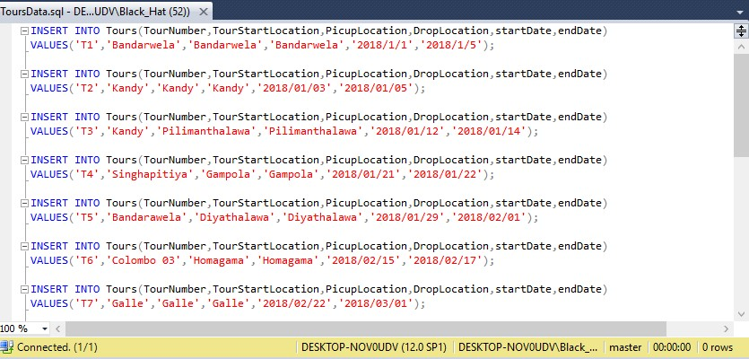

Tour_Participation Table

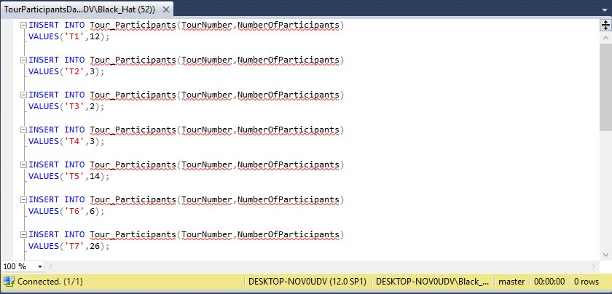

Tour_Itinarary Table

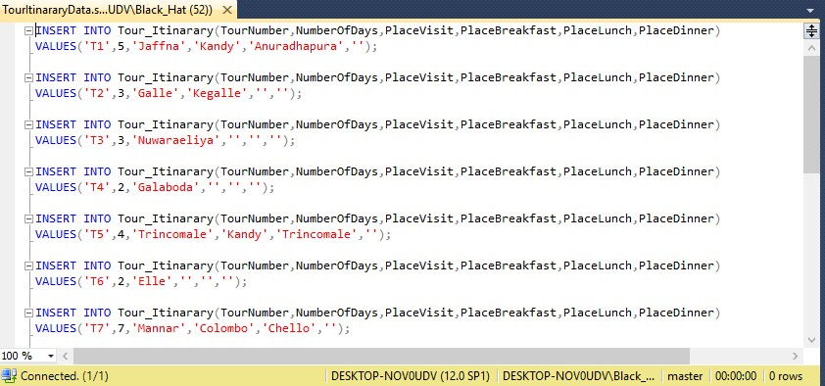

Tour_SpecialActivites Table

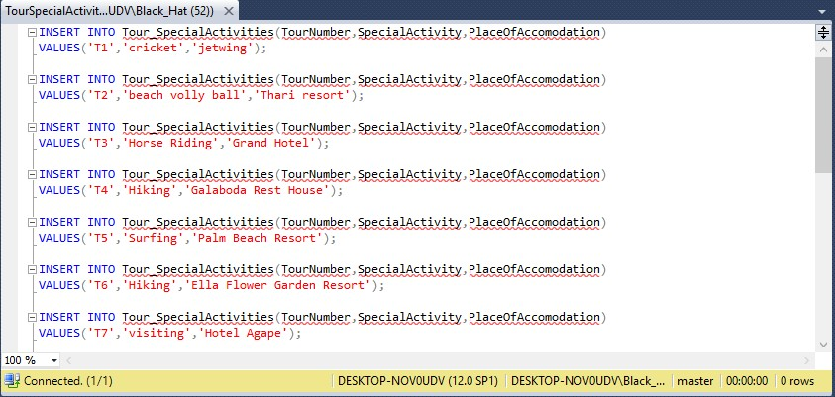

Vehicle Table

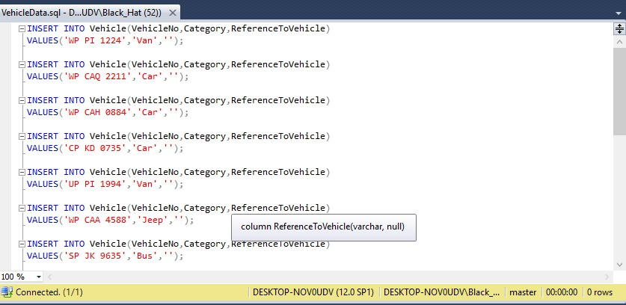

Driver Table

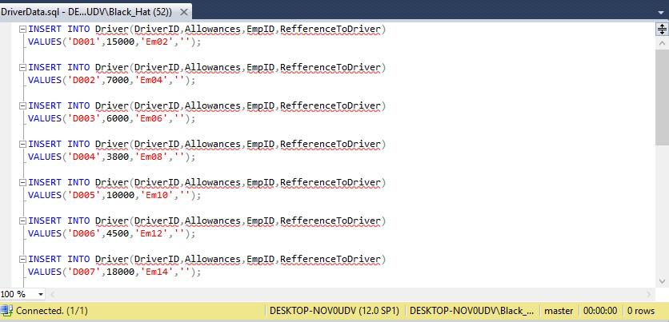

Accomodation Table

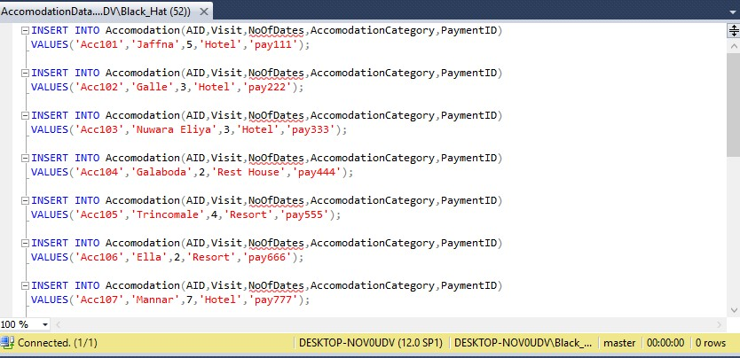

AccomodationzPlace_ToHave Table

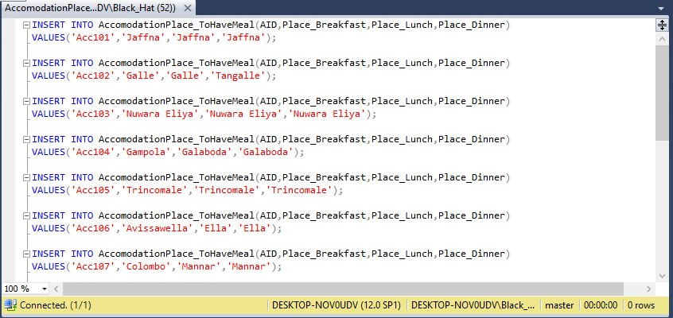

Payment Table

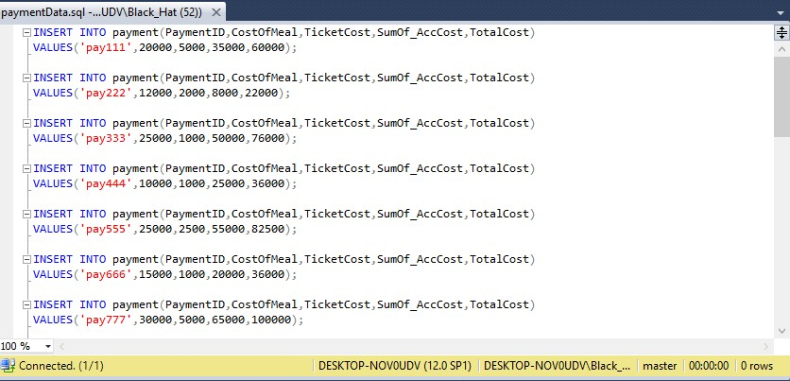

ManagementReport Table

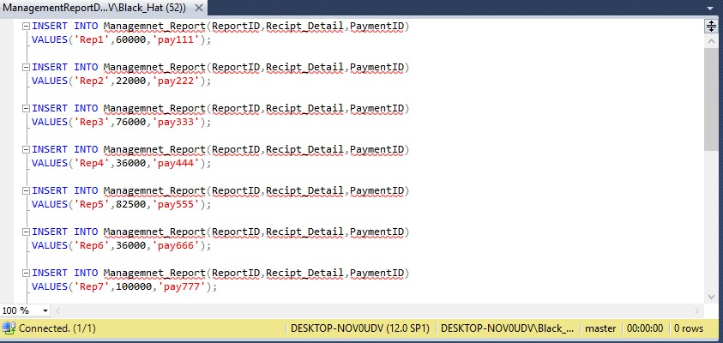

PersonTour Table

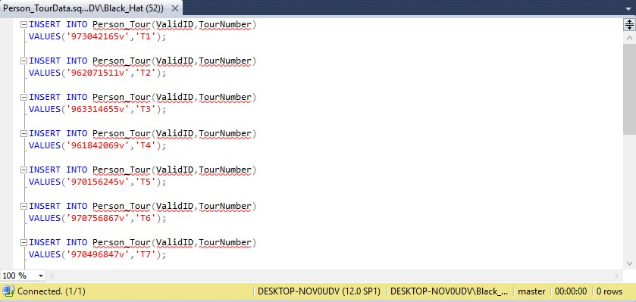

TourAccomodation Table

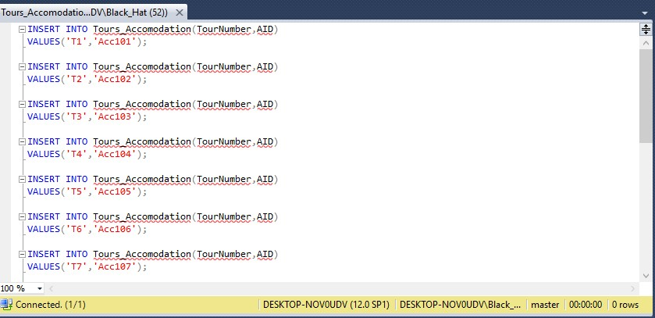

DriverTourVehical Table

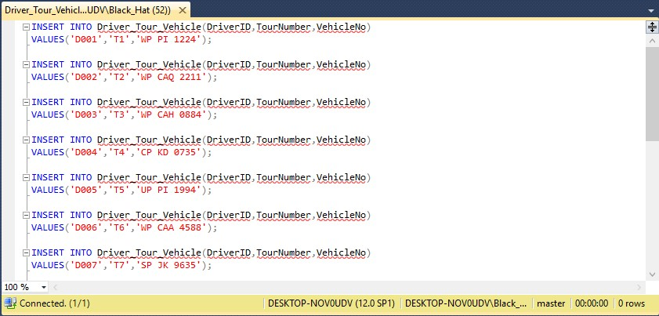

**CREATE TRIGGER Statements**

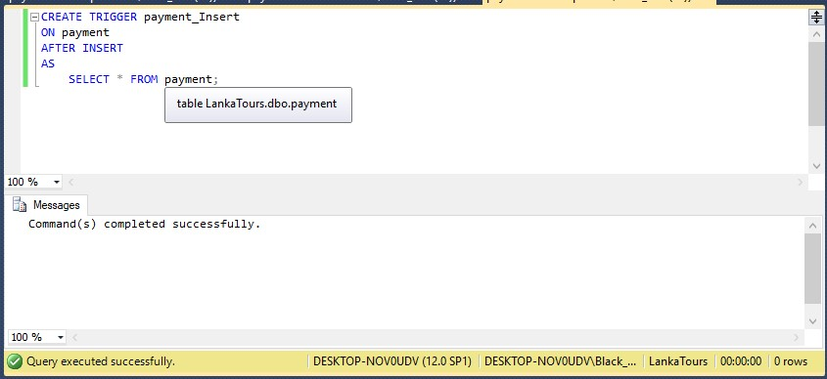Payment_Insert

Payment Execution

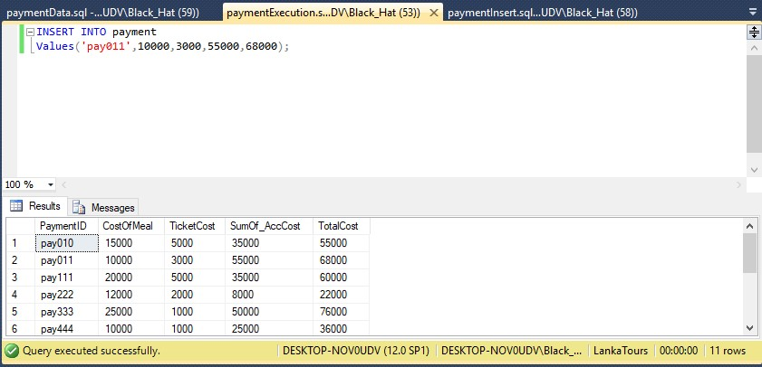

Tour Itinarary Update

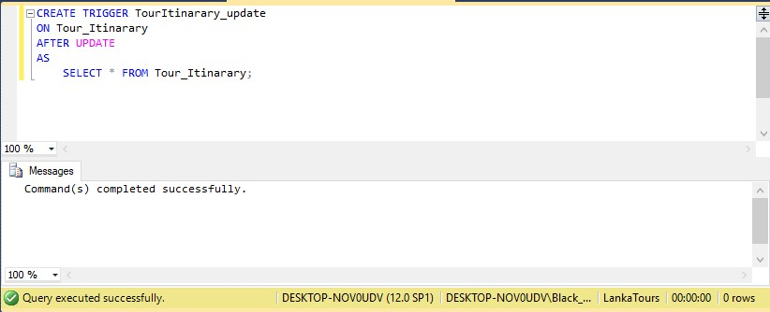

Tour Itinarary Execution

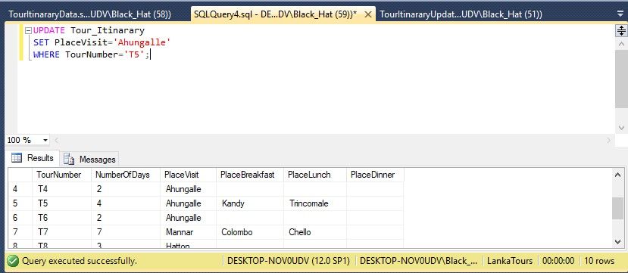

Payment Delete

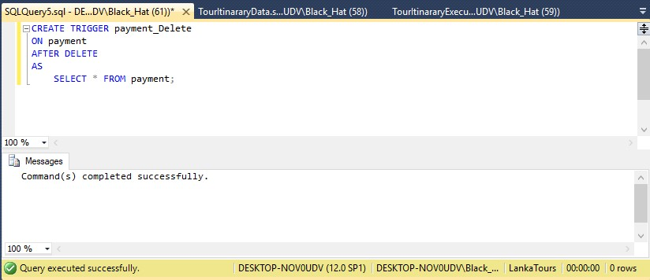

Payment Delete Execution

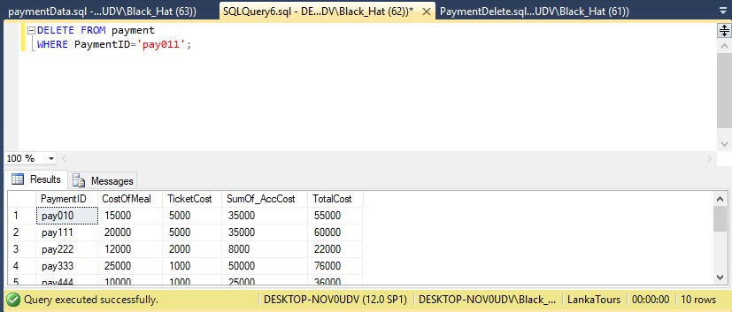

**CREATE FUNCTION Statements**

Payment Function

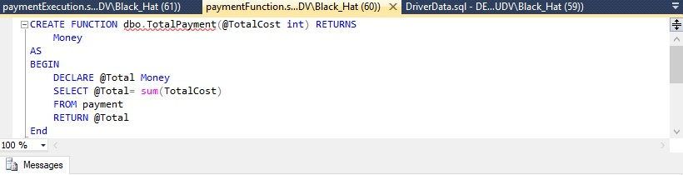

Payment Function Execution

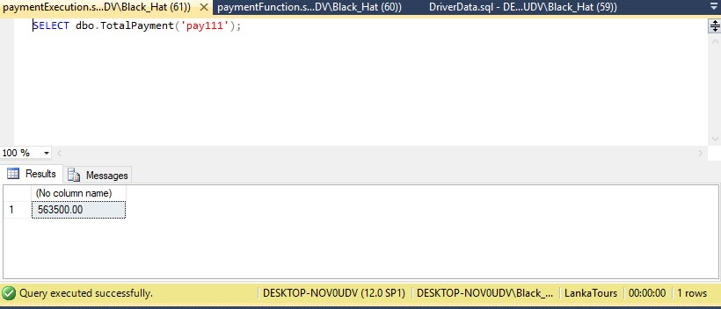

Driver Function

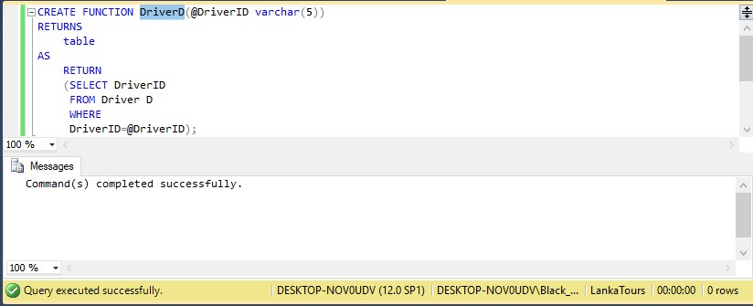

Driver Function Execution

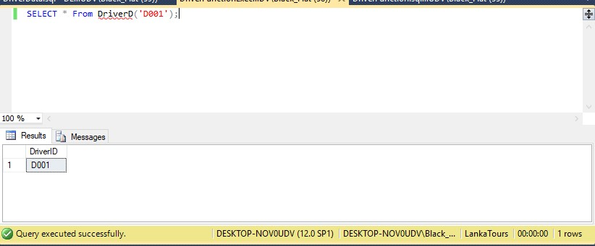

**CREATE VIEW Statements**

Tour Accommodation View

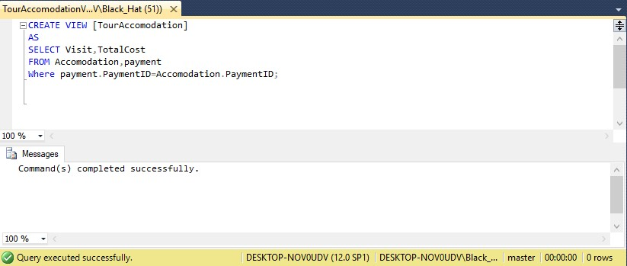

Tour Accommodation View Execution

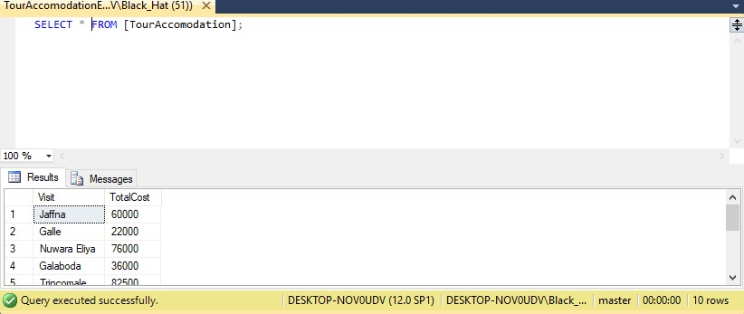

Current Customer View

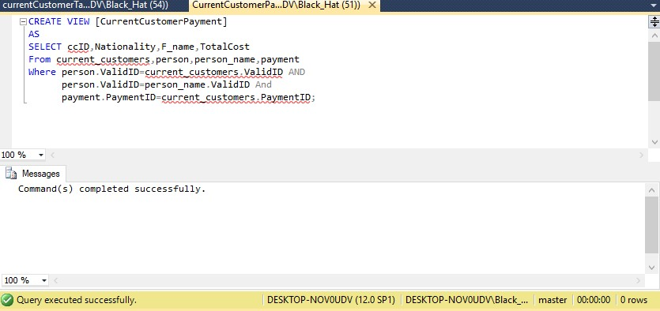

Current Customer Payment View

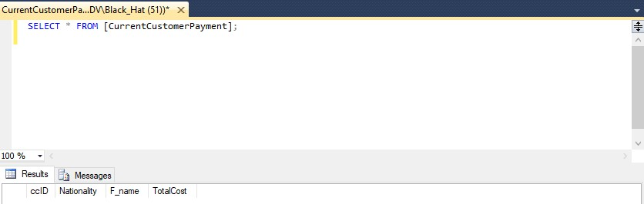

Current Customer Tour View

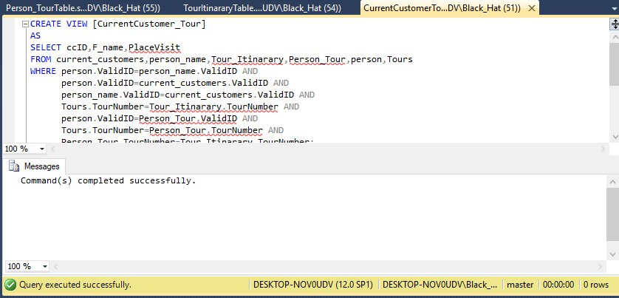

Current Customer Tour Execution

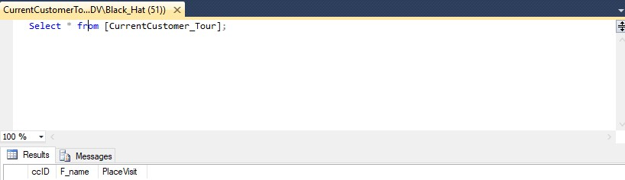

**CREATE PROCEDURES Statements**

Management Report

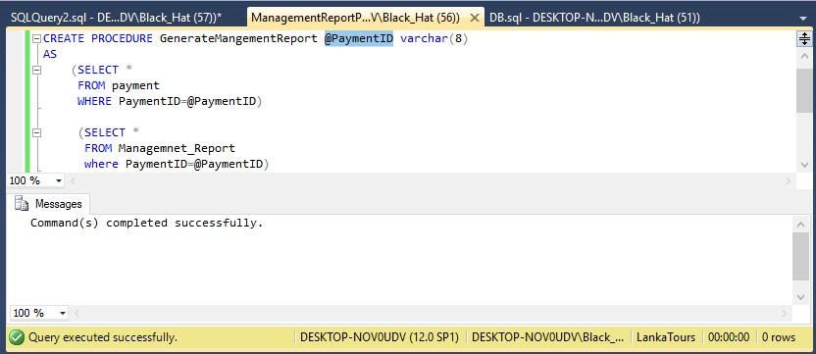

**Management Report Procedure Execution**

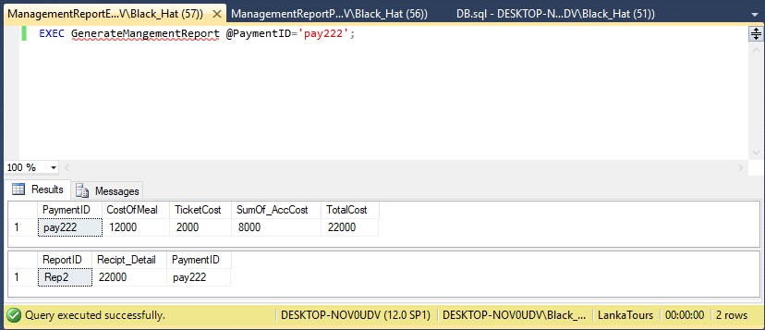

**Accomodation Pay Procedure**

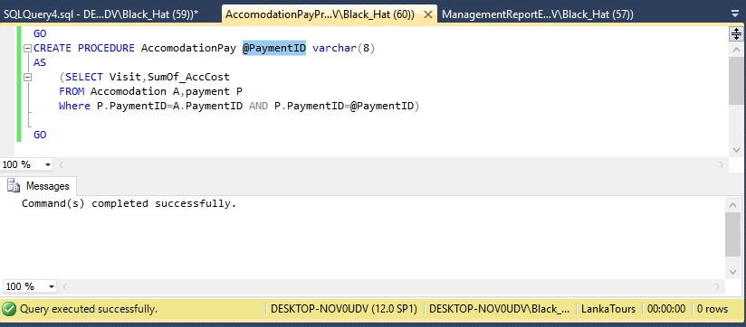

**Accomodation Pay Procedure Execution**

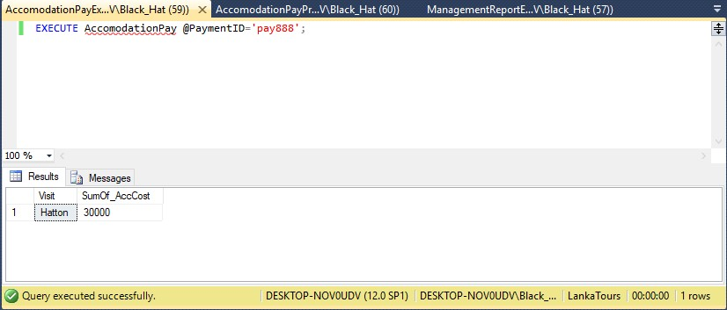

**Critical Appraisal**

After a hours of hard work and dedication we have managed to come up with a good database management system for the Lanka Tours company. But there can be short comings in our database management system technically and theoretically.

We tried to insert more accurate data into the tables to make the database environment more like to a actual touring company database. We tried to use complex triggers, views and procedures to make the dbms more effective. Each of these are created relevant to a practical situation inside a functioning touring company.

Some tables may find difficult to insert data because they are implemented with triggers.

**Comments on further implementation.**

In the project we have given our main priority for the functionality of the database management system.(We have only developed the back end of the dbms). For a better usage a front end can be created. And the whole thing can me make as a standalone software and more user friendly themes, text boxes and buttons can be applied. By that even a person with a lower computer knowledge can easily use the database management system.

More stored procedures can be applied to the database management system so it can decrees the writing of dull queries. And also more advanced triggers can be added to the database to reduce the errors which can be happen when inserting and manipulating data.

**Work Load Matrix**

|  |  |  |  |  |  |
| --- | --- | --- | --- | --- | --- |
| **Index Number** | **ER/EER Diagram** | **Relational Mapping,  Data Normalisation, Data Dictionary** | **Tables, Constraints** | **Views, Triggers** | **Stored Procedures, User Defined Functions** |
| 10602294 |  |  |  |  |  |
| 10602165 |  |  |  |  |  |
| 10601896 |  |  |  |  |  |
| 10601909 |  |  |  |  |  |
| 10601886 |  |  |  |  |  |

**Peer Review Form**

|  |  |  |  |  |  |
| --- | --- | --- | --- | --- | --- |
| **Evaluation Criteria** | 10602294 | 10602165 | 10601896 | 10601909 | 10601886 |
| Attends group meetings regularly and arrives on time. | 4 | 4 | 3 | 4 | 4 |
| Contributes meaningfully to group discussions. | 4 | 3 | 4 | 3 | 3 |
| Completes the tasks on time. | 3 | 3 | 3 | 4 | 4 |
| Prepares work in a quality manner. | 4 | 4 | 4 | 3 | 3 |
| Contributes significantly to the success of the project in a cooperative and supportive attitude. | 3 | 3 | 3 | 3 | 4 |
| **TOTAL** | **18** | **17** | **17** | **17** | **18** |

**TurnitinUK Originality Report**

